Project DocumentationMetro Ticket Reservation

short line

Faculty of Computers and AI  
Cairo University

short line  
Computer Science Major

# Introduction

## 1.1 Motivation

With this large number of Metro passengers, stations become extremely crowded, especially in times previous and after a heavy work day for employees or students in school, as a result of that each person becomes bound to stay at a too long queue in the metro station in front of the ticket window.

In addition to the delays of their journeys, in days like we are living now (a period of serious illness) The infection becomes more common in this crowded queue, as it happens in this period, since these lines cannot be controlled effectively enough. Our goal is to solve the extreme crowding of metro stations by handling all the process of booking a ticket by the mobile app.

Besides what is already mentioned, there are many people who often take the Metro at long intervals ,so they usually don’t know the route to their destination and often they have problems with the sequence of their stations.

So we provide the users of our application with a lot of privileges to help him decide what metro stations he/she should take and what is the route to them. As well as that we provide our users the sequence of the stations he/she should follow to reach their destination.

## 

## 1.2 Background

### 1.2.1 Large number of Metro Passengers:

In a comprehensive report issued by the Egyptian Council of Ministers Information Centre in 2019, which includes numerous figures and details, the Centre indicated in its report published at Facebook, that the number of passengers served by the subway amounts to 3.5 million per day by completing the implementation of the third line of the metro, as well as 1662 trips per day in 2019, compared to 1544 trips per day in 2014.

### 1.2.2 The prevalence of mobile applications:

Mobile Applications, or apps, have taken over in terms of user reach. Here are some stats to support our argument: An annual report on mobility from Ericsson states that smartphones are poised to reach 6.1 billion users by 2020.

Gartner predicts that by the end of 2017, mobile apps downloads will exceed 268 billion times which will generate revenue somewhere over $77 billion.

As a result, organizations or companies are heading to develop mobile applications to make its services easier for users, solve some problems they face or to get more profit by Sponsorship Agreements, given the many users of this application.

### 

### 1.2.3 QR Code Technology:

QR i.e. "Quick Response" code is a 2D matrix code that is designed by keeping two points under consideration. It stores large amounts of data as compared to 1D barcodes and it is decoded at high speed using any handheld device like phones.

QR code provides high data storage capacity, fast scanning, omnidirectional readability, and many other advantages including, error-correction (so that damaged code can also be read successfully) and different types of versions.

Nowadays, a QR code is applied in different application streams related to marketing, security, academics etc. and gain popularity at a really high pace. Day by day more people are getting aware of this technology and use it accordingly. The popularity of QR code grows rapidly with the growth of smartphone users and thus the QR code is rapidly arriving at high levels of acceptance worldwide.

## 1.3 Problem Definition

The problem lies in the effort that people make to buy metro tickets. Besides that, Many people who do not usually use the Metro regularly have issues when they enter the Metro station, they don’t know which line and which direction they should follow to reach their destination station.

In addition to all that mentioned, People usually stuck in routine queues in order to create a metro subscription or to renew it.

## 

## 1.4 Project Objective

handle all the process of reserving a ticket by the mobile app. Use mobile phones instead of Metro smart cards for subscriptions and handle the process of activating or renewing the subscription by the mobile application.

Allow users to find the station they want and provide a described sequence of stations he/she should follow from the start station to their final station.

Let the users easily charge his balance using a secured payment method. Handle the ticket or subscription validation process by using QR Code technology instead of normal tickets.

Develop some features to make the application better and more usable. Our Mobile Application is implemented by Flutter framework to be accessible to every smartphone which support either Android or IOS Operating Systems.

## 1.5 Gantt chart of project time plan

Project gantt chart is divided into two parts to be more clear and these two parts are (analysis and implementation)

### 1.5.1 Analysis gantt chart

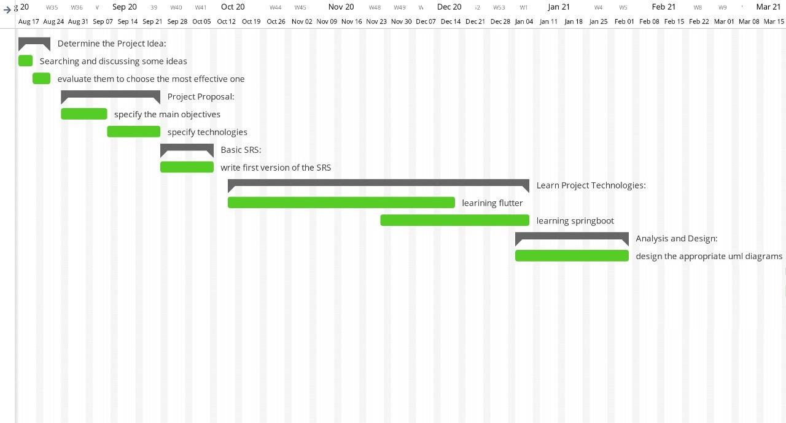

### 1.5.2 Implementation gantt chart

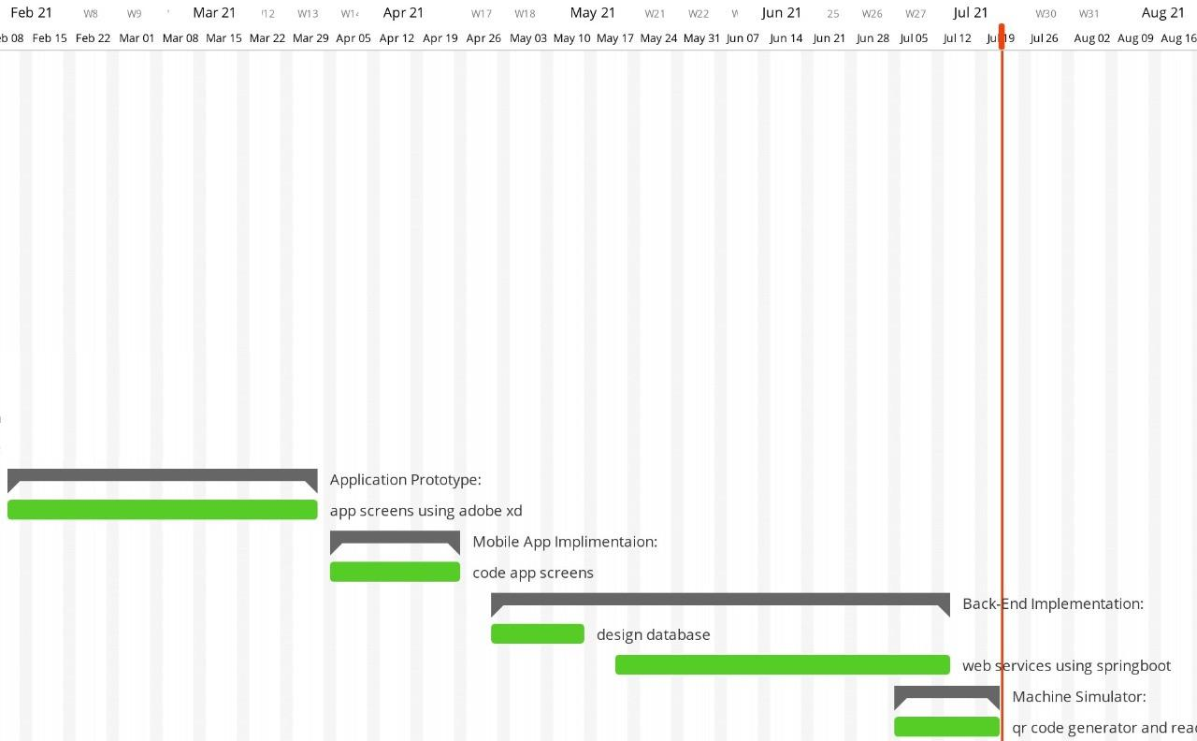

## 1.6 Project development methodology

We work in a project with a combination of iterative and incremental process models with a focus on process adaptability and stakeholder satisfaction by rapid delivery of working software products, and apply (Agile Software Development Methodology).

## 

## 1.7 Software and Hardware Tools

### 1.7.1 Software tools

In this project we have used many software tools to make this project reliable with high performance such as we have used Adobe XD to build prototype screens for the application. Beside that, we have used Dart programming language in Flutter framework to implement the actual application screens and logic.

We have built our database by Mysql via Mysql workbench.And we developed the back-end APIs by java using Spring Boot framework.

Moreover, We have used HTML, CSS, Jquery and Bootstrap to create web services for the application admin.

### 1.7.2 Hardware tools

We were planning to make our ticket reader like the real metro reader machine. So, We have tried to communicate with the Cairo Metro organization to gain some information about how ticket reader machines read and write on the ticket but we didn’t get any suitable answer.

In order to do that, we didn’t used any hardware tools but we have developed a simulation app to act like a reader/writer machine.

## 

## 1.8 Report Organization

In the following chapter we will be talking about

* Some related works to our project

Examples of matching applications and the differences between us and them.

* System analysis

We will talk about functional, nonfunctional requirements and Use Case Diagrams.

* System design

UML Diagrams like Component Diagram, Class Diagram, Sequence Diagrams and ERD.

* Implementation and testing

System running and samples of the applied test cases.

# Related Work

There are some Applications that similar to our App, for example:

* Q Ticketing: Metro is the Metropolitan Transit Authority of Harris County, serving the Greater Houston, Texas region with safe, clean, reliable, accessible and friendly public transportation services.

##### Link for the app:<https://play.google.com/store/apps/details?id=org.ridemetro.qticketing&hl=ar&gl=US>

* Metrolink: With the Metrolink App, which serves Southern California, you can securely purchase Metrolink One-Way, Round-Trip tickets, 7-Day, Monthly and Weekend Day Passes in seconds. Purchasing a ticket is easy: select your trip & ticket type, enter your payment card information, activate your ticket prior to boarding and your device is your ticket.

##### Link for the app:

##### [Metrolink - التطبيقات على Google Play](https://play.google.com/store/apps/details?id=com.justride.metrolink&hl=ar&gl=US)

* Ridlr App: Ridlr is a public transport ticketing and commuting app that’s apt for your daily intra-city travel needs which serve Delhi & Mumbai, India.

##### Link for the app:

##### [Metro ( Delhi & Mumbai) and Bus Tickets & Passes - التطبيقات على Google Play](https://play.google.com/store/apps/details?id=com.ridlr&hl=ar&gl=US)

Our Application is similar with these Applications in having common Features like:

* Handling all the process of booking a ticket by the mobile app.
* Secure ticket purchasing.
* User device is his ticket.
* Easy to select User’s origin and destination to purchase.

# System Analysis

## 3.1 Project specification

### 3.1.1 Functional requirement

The following table illustrates functional requirements where a functional requirement defines a function of a software system or its component. Functional requirements may be technical details, data manipulation.

| No. | **Functional Requirements** |
| --- | --- |
| 1 | The system shall allow users to register in the Application. |
| 2 | The system shall allow users to login in the Application. |
| 3 | The system shall allow users to charge their wallet using a payment method. |
| 4 | The system shall allow users to buy one ticket or more at the same process. |
| 5 | The system shall allow users to save tickets on the mobile’s file storage to be used offline. |
| 6 | The system shall allow users to determine the price of a ticket using source and destination. |
| 7 | The system shall allow users to determine the closest station from a specific location. |
| 8 | The system shall allow users to determine estimated time for the entire trip (from Specific Station to another). |
| 9 | The system shall allow users to get full directions (path) to go from one subway to another. |
| 10 | The system shall allow users to apply for or renew a normal subscription. |
| 11 | The system shall allow Admins to add, update and delete basic tickets if any changes are needed. |
| 12 | There is a map showing all the subway lines. |

### 3.1.2 Non-functional requirement

##### 3.1.2.1 Performance Requirements

Using cloud server storage for our database will improve scalability as we will have the ability to increase or decrease IT resources as needed to meet changing demand.

This also will make the login information be verified within less seconds. Response time of the system will not take a long time, almost in a few seconds. The system works 24 hours per day 7 days a week. The passengers’ information must be saved in the database in a few minutes after the end of registration.

##### 3.1.2.2 Security Requirements

Using a firewall that can help protect your network by filtering traffic and blocking outsiders from gaining unauthorized access to the private data which will protect the integrity and avoid changes or access by unauthorized users.

Consideration of the security of the system has a great advantage for this system, because the database should be secured from unauthorized users. Only authorized users can get access to the database. To prevent unauthorized users, the user should have their username and password that help them to login to the system. Additionally, the users should have to take care of their own username and password. They should have to keep it a secret manner.

##### 3.1.2.3 Software Quality Attributes

Should be easily maintainable, using the MVC design pattern will make the system easy to upgrade and make adjustments as it is known, every system needs to be maintained and modified, so the code will be readable.

The system will check user inputs to the system to handle errors. It handles and shows errors by displaying the error message when the user enters invalid input.

Our system describes the logical characteristics of each interface between the system and the users.

This may include any graphical user interface (GUI) standards or product family style guides, screen layout constraints, standard buttons and functions that will appear on every screen, error message display standards, and so on. so, our system does all these functions in an easy and efficient way. In other words, the system is user interactive.